--------------- WINDOW FUNCTIONS --------------------

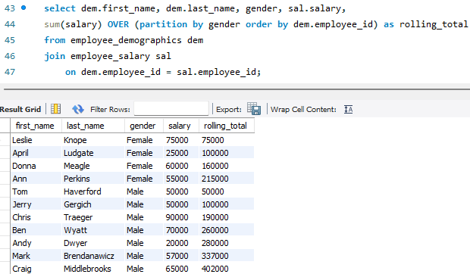

------------------------------------ CTEs -----------------------------------------

---------------------------- STORED PROCEDURES ----------------------------

